**Dietary fibers induce baseline-dependent, ecology-driven dynamics of murine gut microbiota and short-chain fatty acids**

**Abstract**

Dietary fibers are commonly used as an intervention of gut microbiota to promote the production of short-chain fatty acids (SCFA), which are important for host health. Despite the functional roles of gut bacteria key to dietary fiber responses have been catalogued, our understanding of the response dynamics and its individuality across microbiomes remain limited due to the lack of time series data and systems approaches for longitudinal data analysis. To address the challenge in a controlled setting, we continuously monitored microbiome profiles (absolute abundance) and targeted metabolomics of adult mice with distinct baseline microbiota undergoing intervention of inulin and resistant starch over four weeks. Generally, inulin stimulated stronger short-term responses than resistant starch and shifted both gut microbiota composition and SCFA concentration into new steady states after transient overshoot behavior, which can be explained by initial rapid growth of several inulin responders (e.g., Bacteroides acidifaciens and unclassified Muribaculaceae) and their competitions near carrying capacity. However, the dynamical responses of ~10% bacterial species and the majority of SCFAs exhibited quantitative or even qualitative baseline-dependency after treatments of both fibers. In accordance with previous studies in humans, the strong baseline-dependency poses a great challenge when extrapolating prediction of SCFA concentration from gut microbiota to unobserved baseline composition. This work reveals time- and baseline-dependency of dietary fiber responses as major challenges for personalized nutritional therapies and the necessity to search for predictive microbiota variables other than composition.

**Main text figures:**

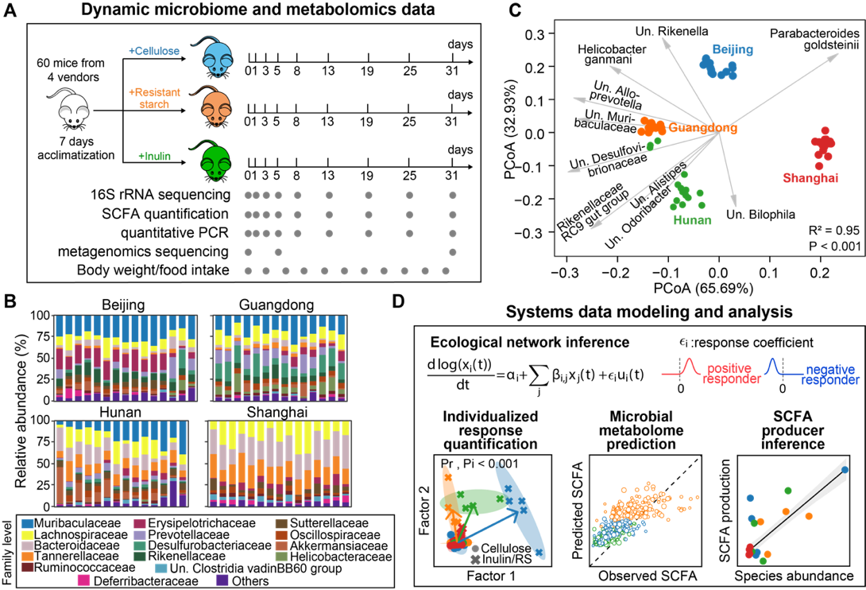

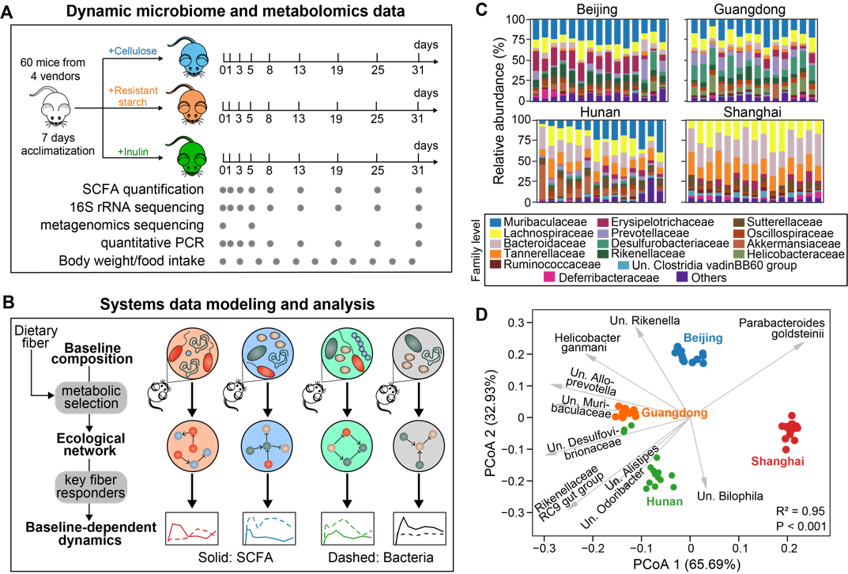

**Figure 1.** **Experimental design and computational framework for this study. A.** Schematics of the experiments performed on a mouse model. Gray dots indicate the days on which longitudinal fecal samples, microbiome and metabolomics data were collected. SCFA: short-chain fatty acid. **B.** An ecology-centric view of baseline-dependent dynamical fiber responses. We used mathematical modeling to infer ecological network under diet selection and key fiber responders that determine baseline dependency of both microbiome and SCFA dynamics. **C.** Baseline gut microbiota composition of isogenic mice purchased from four different vendors, labelled as Beijing, Guangdong, Hunan and Shanghai. **D.** PCoA (principal coordinate analysis) plot of the baseline microbiota composition. Dots represent baseline samples and gray arrows represent dominant bacterial species in the samples. The sample whose dot projects furthest in the direction of a species has the highest relative abundance of that species. R2 and P-value were obtained from Adonis analysis, which tests for baseline differences across the four vendors. For panels C, D, taxonomic labels w/ “Un.” group bacteria that are unclassified or uncultured at lower taxonomic ranks.

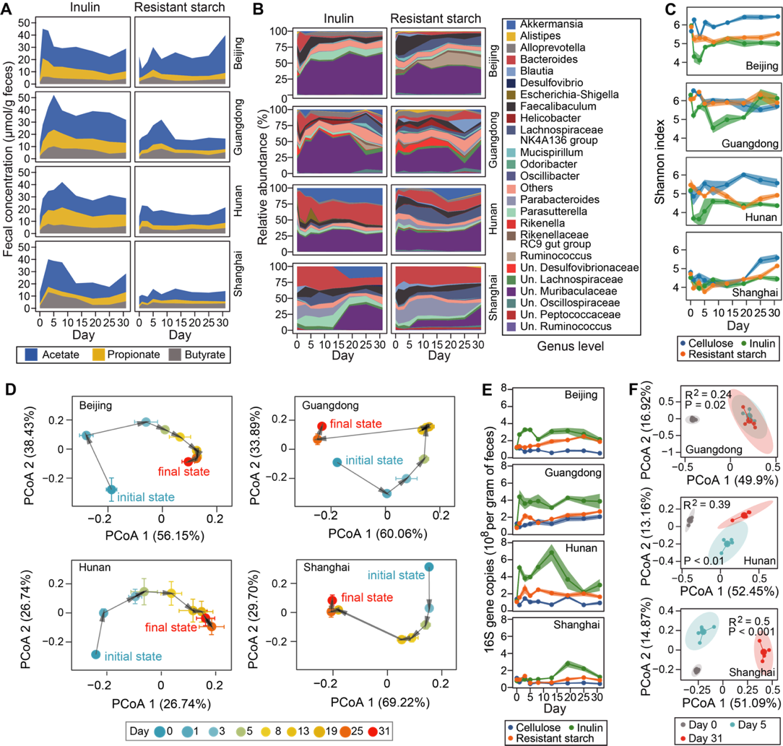

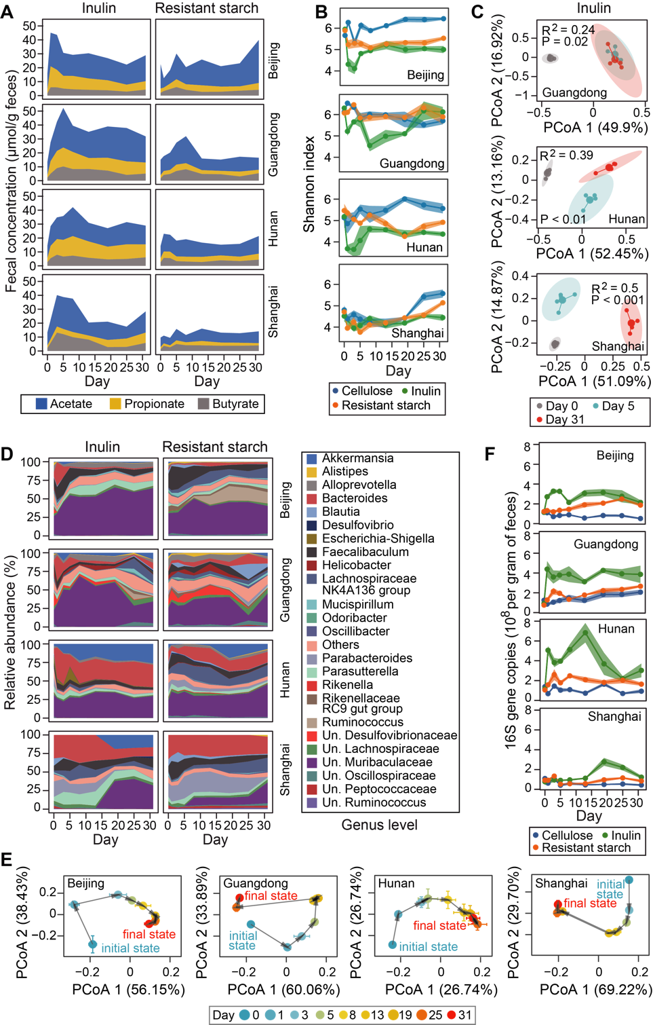

**Figure 2.** **Dynamical responses of short-chain fatty acid (SCFA) metabolism and murine gut microbiome to dietary fiber intervention. A**-**C.** Temporal changes in fecal concentration of three major SCFAs (A), microbiota alpha diversity (B), and gene abundances of mice gut metagenome (C) during four weeks’ dietary fiber intervention. Both SCFA concentration and microbiota diversity show short-term overshoot and long-term steady-state responses to inulin treatment. For panel B, taxonomic labels w/ “Un.” group bacteria that are unclassified or uncultured at lower taxonomic ranks. For panel C, R2 and P-value were obtained from Adonis analysis, which tests for the difference in gene abundances during intervention (day 0: baseline, day 5: short-term response, day 31: long-term response). **D**,**E.** The response trajectories of gut microbiota composition to inulin as well as their PCoA (principal coordinate analysis) plots (E) indicate compositional transition and convergence to a new steady state. **F**. Total bacterial density measured by quantitative PCR. **T**he heights of stacked bands (panels A, D), lines (panel B, F) or dots (panel E) represent the mean values across mice within the same vendor and shading areas (panel B, F) or error bars (panel E) represent standard error of the mean.

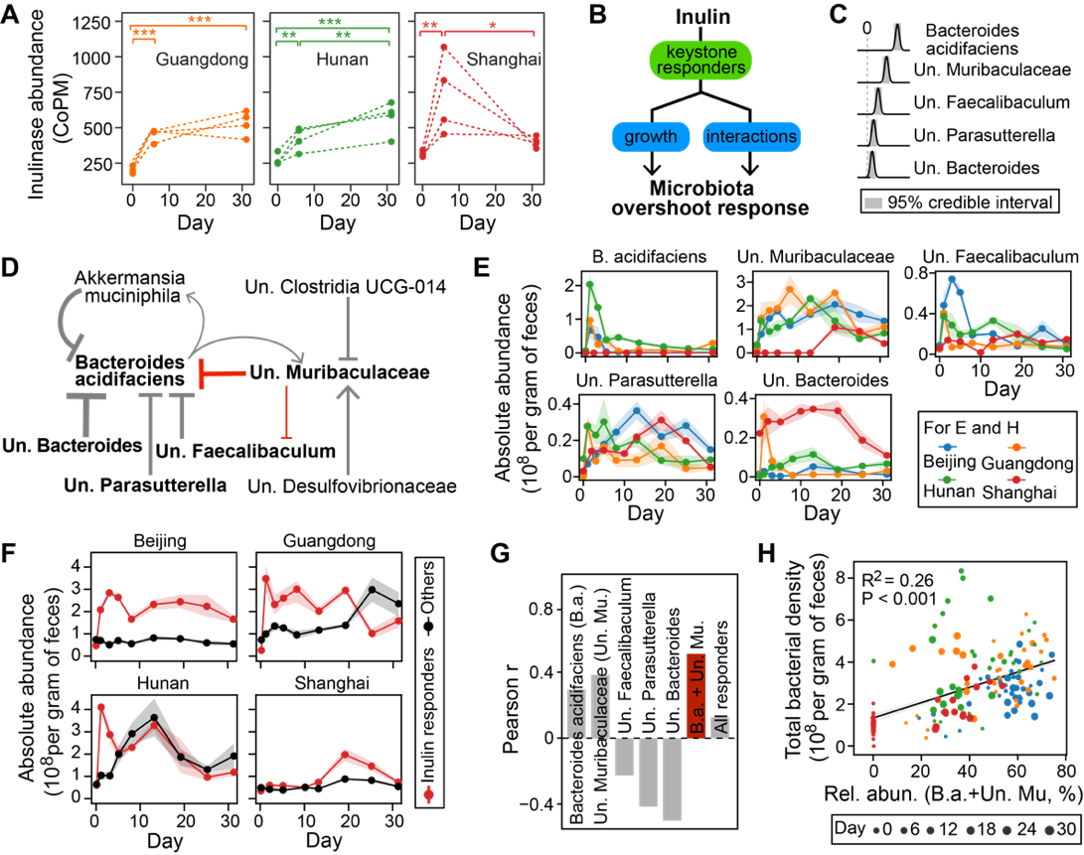



**Figure 3. Microbiota dynamics in response to inulin is driven by several key** **responders****. A.** Increased expression of inulinase genes following inulin treatment. Each dotted line represents an individual mouse. *: P < 0.05; **: P < 0.01; ***: P < 0.001. **B**. Generalized Lotka-Volterra model combined with Bayesian statistics to infer inulin responders and associated ecological interactions. **C.** Posterior distribution of five bacterial species with significant growth responses. **D**,**E**The(D) and individual (E) of five shown in panel Cfive show heterogeneous responses but eterminedynamics. **F.** Core ecological interaction network constituted by significant interspecific interactions (self-interactions not shown). Inulin responders (bold font) and key inhibitions (red arrows) are highlighted. Point and blunt arrows represent positive and negative interactions respectively. The arrow thickness is proportional to the posterior mean of the corresponding interaction coefficient. For panels C, F, significance was determined when 95% credible interval does not include 0. For panels C, E, F, taxonomic labels w/ “Un.” group bacteria that are unclassified or uncultured at lower taxonomic ranks**.**

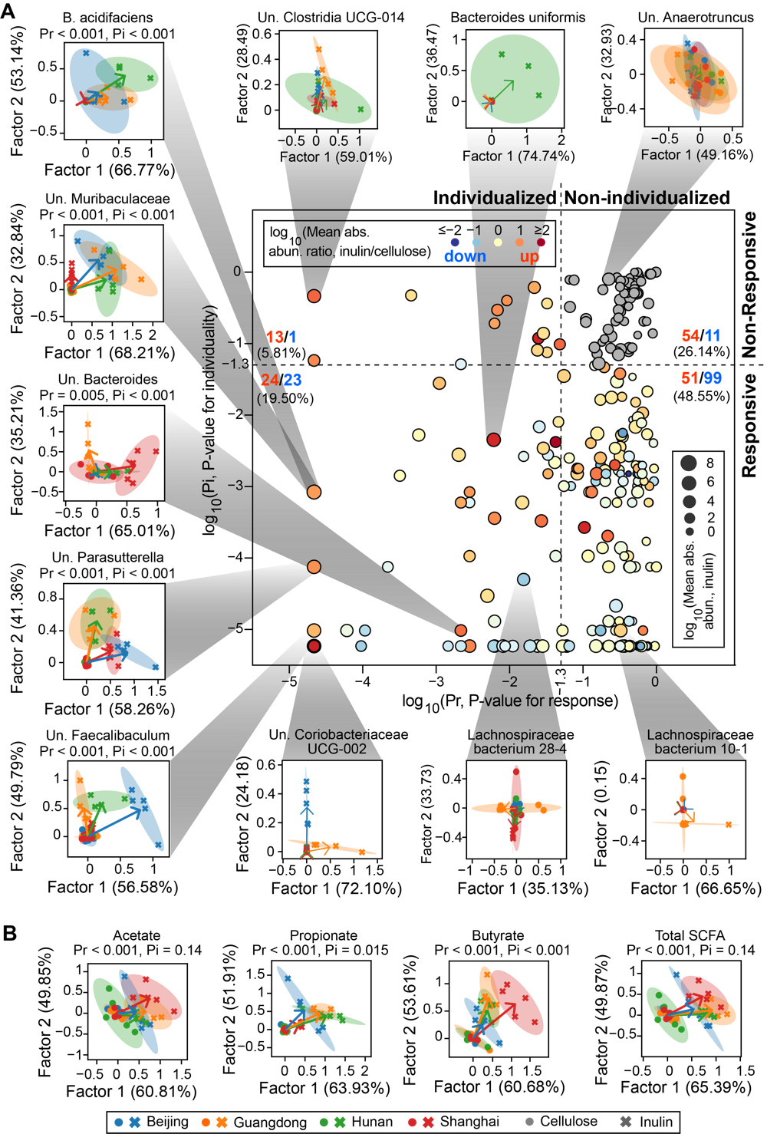

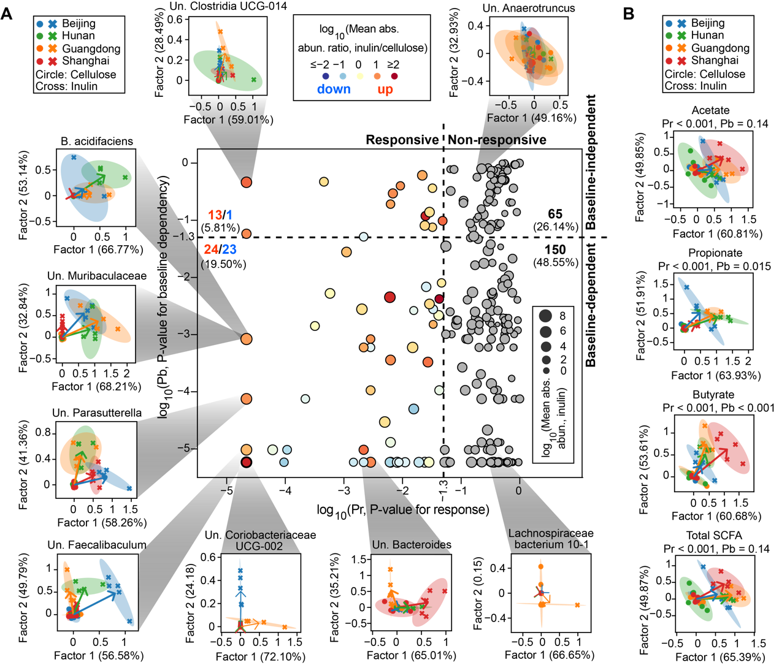

**Figure 4.** **Visualization and quantitative significance test of baseline-dependent responses of bacterial species (A) and short-chain fatty acids (SCFAs) (B) to inulin intervention.** The scatter plot in panel A distinguishes four different scenarios of baseline-dependent responses depending on the P-values for significance test of responsiveness (Pr) and baseline-dependency (Pb). The non-responsive bacterial species are marked as gray dots, while the responsive ones are colored by the ratio of their averaged absolute abundances (abs. abun.) between inulin and cellulose group. We displayed the inulin-stimulated longitudinal responses of bacterial species and SCFAs, relative to their corresponding responses in the cellulose group, in a reduced two-dimensional (2D) space spanned by factor 1 and factor 2 extracted using sequential non-negative matrix factorization (see Methods for details). In the 2D visualizations, each symbol represents a mouse (dots: cellulose group, crosses: inulin group) and all mice data from the same vendor under the same dietary fiber treatment was used to fit an eclipse. For each vendor, an arrow was drawn from the eclipse center of the vendor under cellulose treatment (standardized to the origin) to that under the inulin treatment. Numbers in parentheses on x- and y-axis labels indicate factor loadings. Taxonomic labels w/ “Un.” group bacteria that are unclassified or uncultured at lower taxonomic ranks.

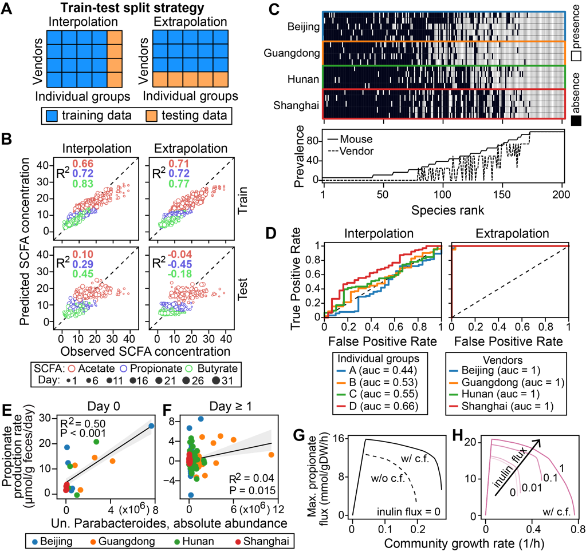



**Figure 5.** **Robust learning of microbiome-metabolome relationship** **is** **challenging due to baseline-dependency. A**. Two data-splitting strategies for testing model performance using machine learning models. Mice in the testing sets were randomly selected on a one-per-vendor basis for “interpolation” and exclusively selected from a single vendor for “extrapolation”. **B**.Training and testing accuracy in Random Forest regression models trained on absolute abundance of bacterial species. Data in day 0 were removed from the analysis. **C**. Presence (threshold: 0.001%) and prevalence of bacterial species in baseline microbiota across mice and vendors. Species absent in any mouse baseline sample were not shown. In the bottom panel, the prevalence score of a species across mice (solid line) was defined as the fraction of mice that contains this species in their baseline microbiota and that across vendors (dashed line) was the fraction of vendors whose mice all contain this species. **D**. Receiver operating characteristic (ROC) curve analysis of the similarity between training and testing datasets. A Random Forest classifier trained to discriminate the two datasets outputs area under the ROC curve (auc) as a similarity score (see Methods for details).

**Supplementary figures:**

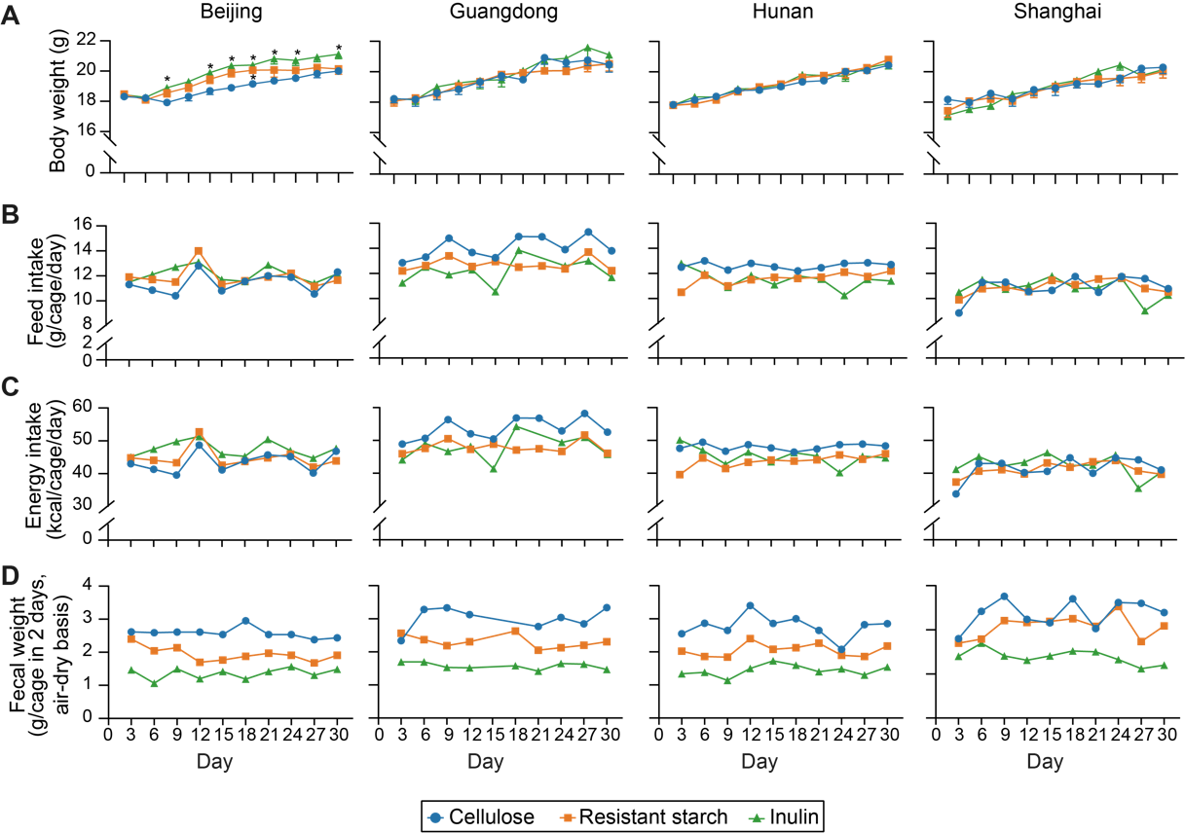

**Figure S1. (Related to Fig. 2) Effects of inulin or resistant starch on (A) body weight, (B) daily food intake, (C) daily energy intake, and (D) 48-hr fecal sample weight of mice receiving diet supplementation used in this study.** Each symbol represents the mean body weight in panel A or a single data point in panels B-D. The body weight data were analyzed by ordinary one-way ANOVA with Turkey post hoc test between inulin or resistant starch and cellulose group. *, P < 0.05.

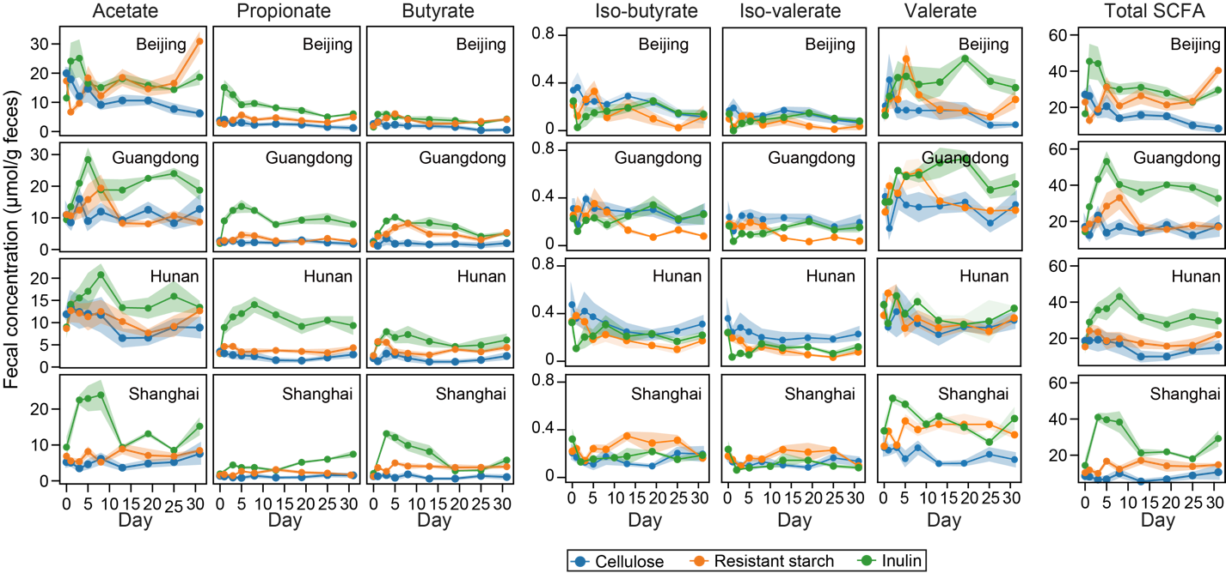

**Figure S2. (Related to Fig. 2) Dynamics of fecal short-chain fatty acid (SCFA) concentration following dietary fiber intervention.** Lines represent mean concentrations and shading areas represent standard error of the mean.

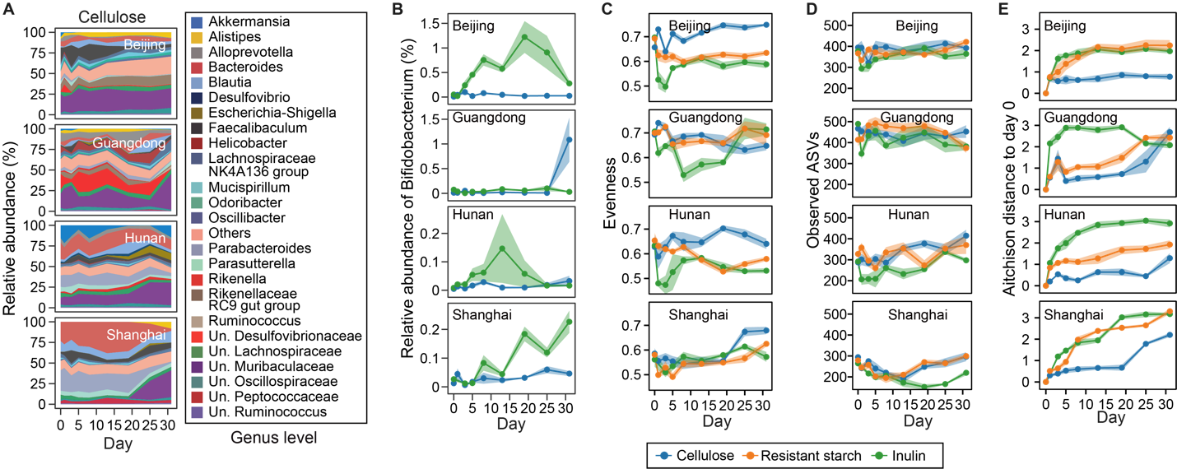

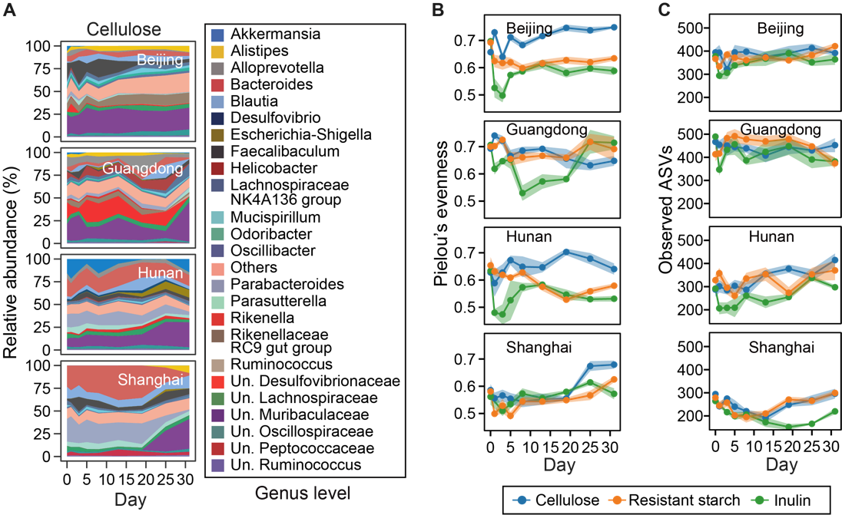

**Figure S3. (Related to Fig. 2) Dynamics of cellulose-group microbiota composition (A), evenness (B), and number of observed ASVs (C) following dietary fiber intervention.** For panel A, taxonomic labels w/ “Un.” group bacteria that are unclassified or uncultured at lower taxonomic ranks. For all panels, the heights of stacked bands (panel A) or lines (panels B, C) represent mean values across mice within the same vendor and shading areas (panels B, C) represent standard error of the mean.

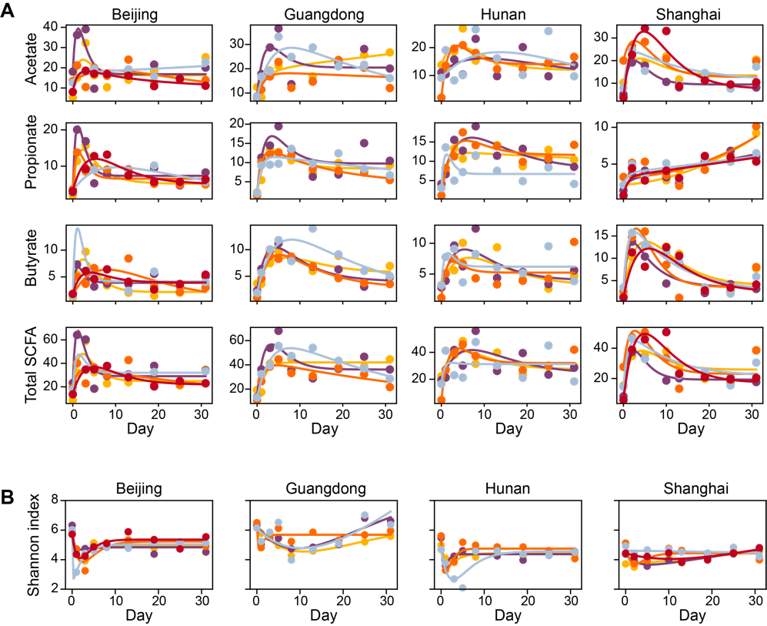

**Figure S4. (Related to Fig. 2) Fitting a harmonic oscillator model to the dynamics of short-chain fatty acids (A) and Shannon diversity (B).** Dots represent data and lines represent simulations using the best-fit parameter values. Both lines and dots are color-coded on a per-mouse basis.

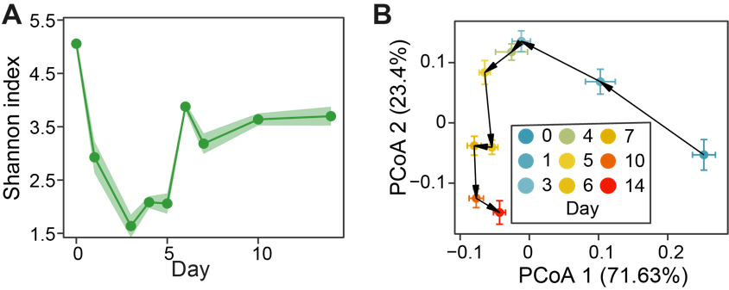

**Figure S5. (Related to Fig. 2) Reanalysis of data from Chijiwa et al., 2020, where** **a similar experiment was performed to observe the gut microbiota dynamics following inulin treatment in a mouse model.** **A**. Alpha diversity. **B**. The averaged response trajectory of gut microbiota in PCoA (principal coordinate analysis) ordination scatter plot. Each dot represents the mean principal coordinate score of all mice and the corresponding error bar represents the standard error of the mean.

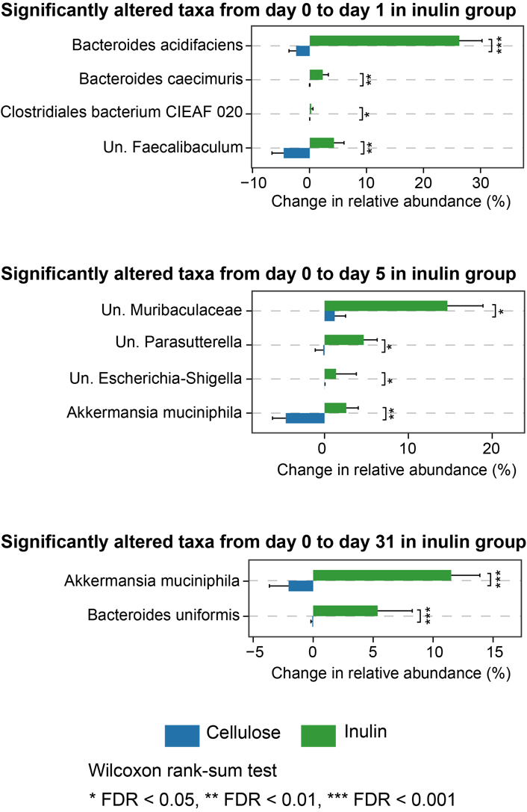

**Figure S6.** **(Related to Fig. 3) Significantly altered bacterial species in relative abundance between inulin and cellulose groups.** The identified species vary depending on the day of observation.

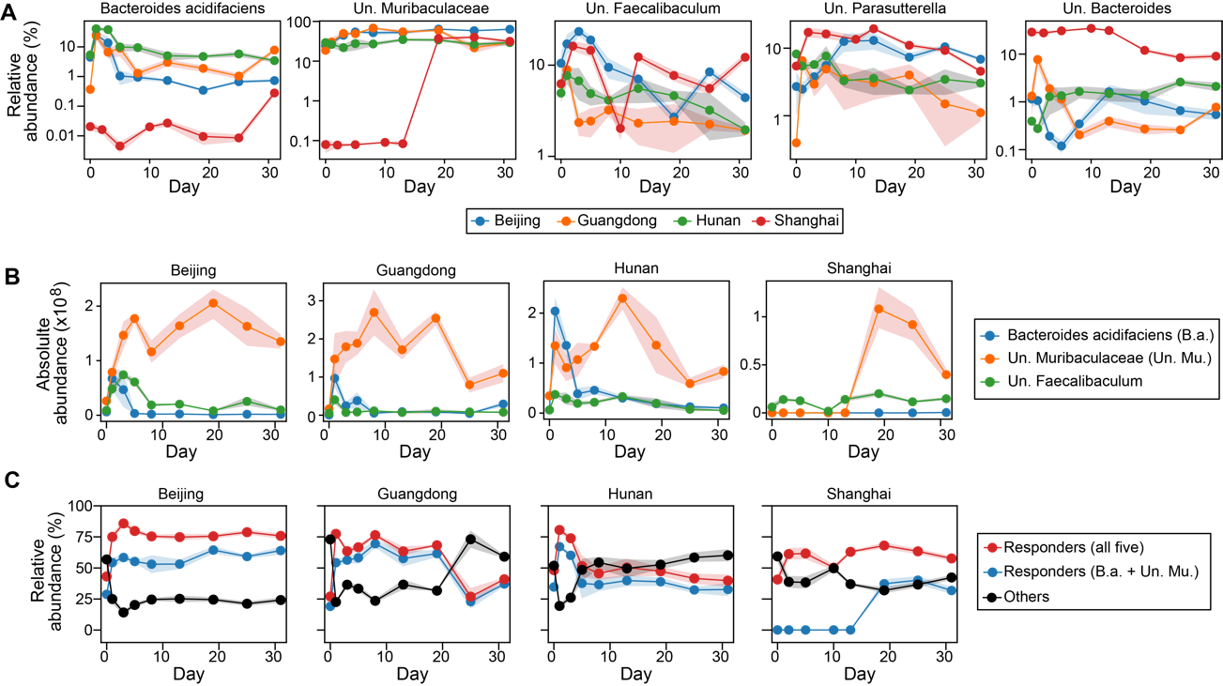

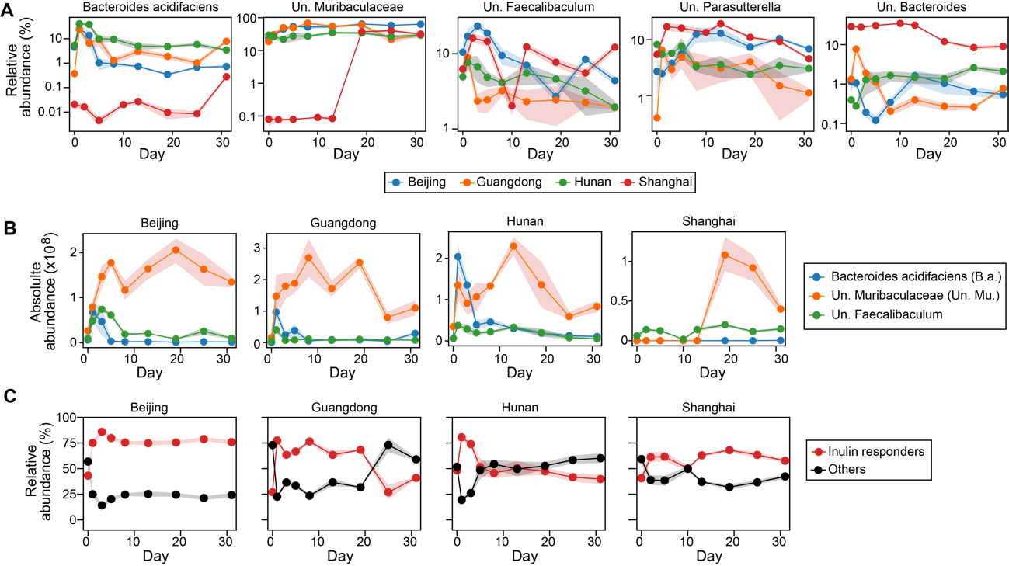

**Figure S7. (Related to Fig. 3) Dynamics of inulin responders.** **A**. Relative abundance of each inulin responder inferred from ecological network model. **B**. Three responders that might compete for inulin (see the main text Fig. 3F for inferred interspecific interactions). **C**. Comparison of total relative abundance between inulin responders and other bacterial species.

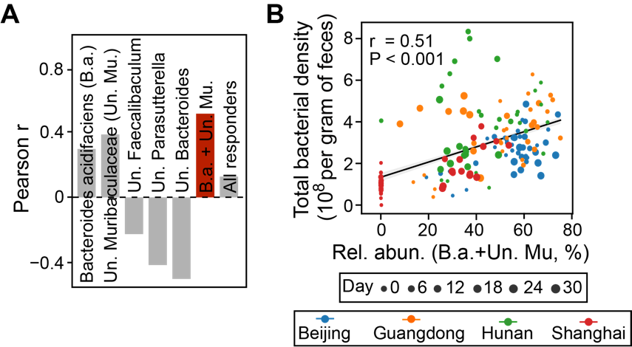

**Figure S8. (Related to Fig. 3) Prediction of total bacterial density (i.e., absolute abundance) from relative abundance of inulin responders.** **A**. Pearson correlation for different combinations of inulin responders. The red bar has the highest correlation coefficient. **B**. Scatter plot showing the positive correlation of the combined relative abundance of Bacteroides acidifaciens (B.a.) and unclassified Muribaculaceae (Un. Mu.) with total bacterial density. Gray line: linear regression (Pearson r and P-value are indicated in the plot); shading area: standard error of the regression.

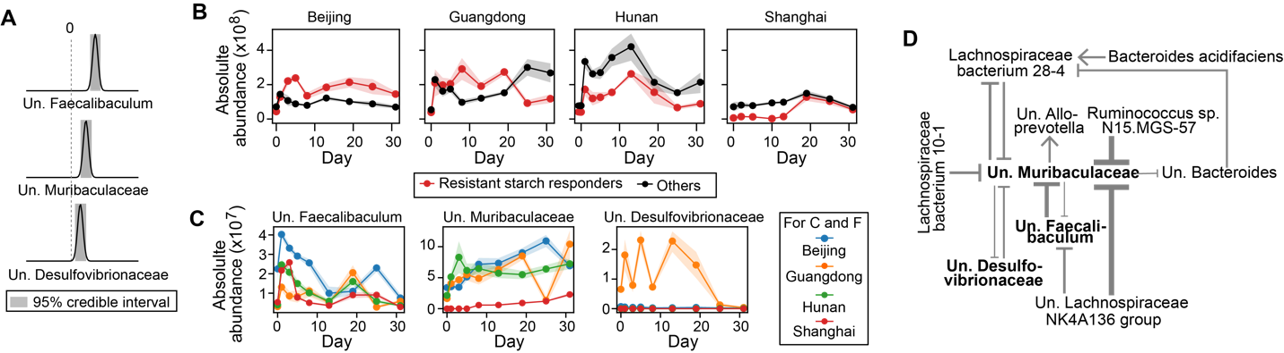

**Figure S9. (Related to Fig. 3) Inferring bacterial responders to resistant starch intervention and associated ecological interaction network.** The same figure legend applies as in the main text Fig. 3C-H (the same order).

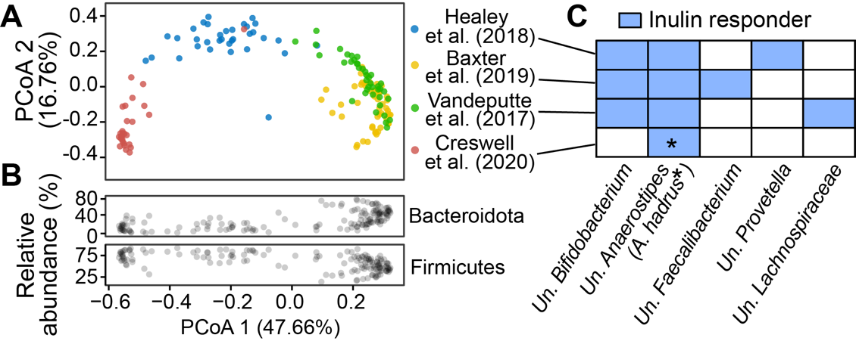

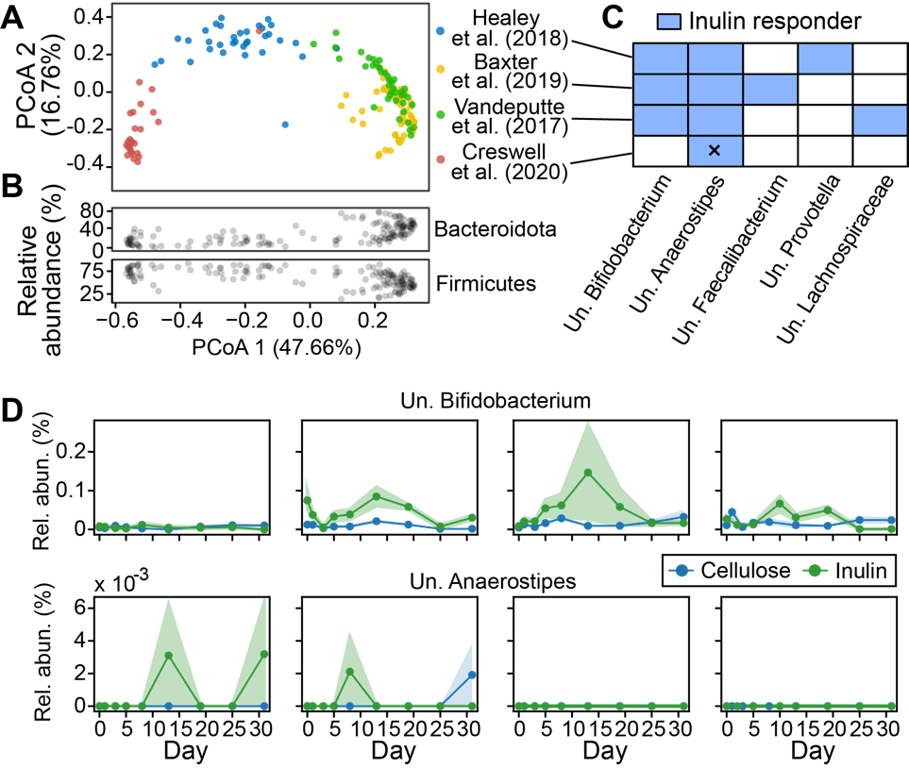

**Figure S10. (Related to Fig. 3) Inference of inulin responders in human gut microbiome. A.** Principal coordinate analysis (PCoA) of baseline human gut microbiota (Bray-Curtis distance matrix of 16S or shallow shotgun metagenomics) in four cohorts of literature studies with inulin intervention. **B.** Relative abundance of two major bacterial phyla in the same samples shown in panel A. **C.** Positive inulin responders identified from the four literature studies in panel A. We used the same generalized Lotka-Volterra model and Bayesian inference framework as we used for our mouse experiments (see Methods in the main text for details). Cross (x) represents an exception that the inferred responder (Anaerostipes hadrus) can be classified to the species level. **D**. Relative abundance (rel. abun.) of Un. Bifidobacterium and Un. Anaerostipes in the mouse gut.

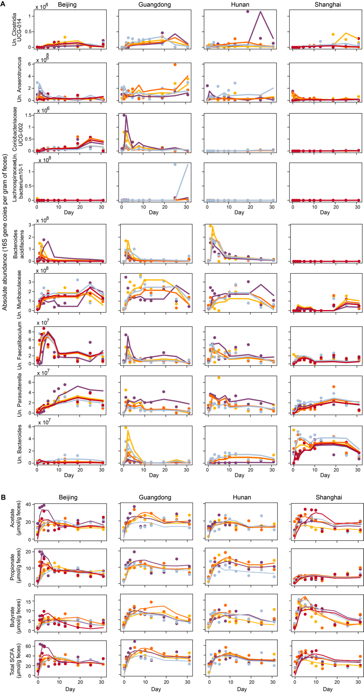

**Figure S11. (Related to Fig. 4) Reconstructed time series (lines) of selected bacterial species (A) and short-chain fatty acids (B) in the main text Fig. 4 using the first two factors of sequential Non-negative matrix factorization.** Dots represent observations and both lines and dots are color-coded on a per-mouse basis.

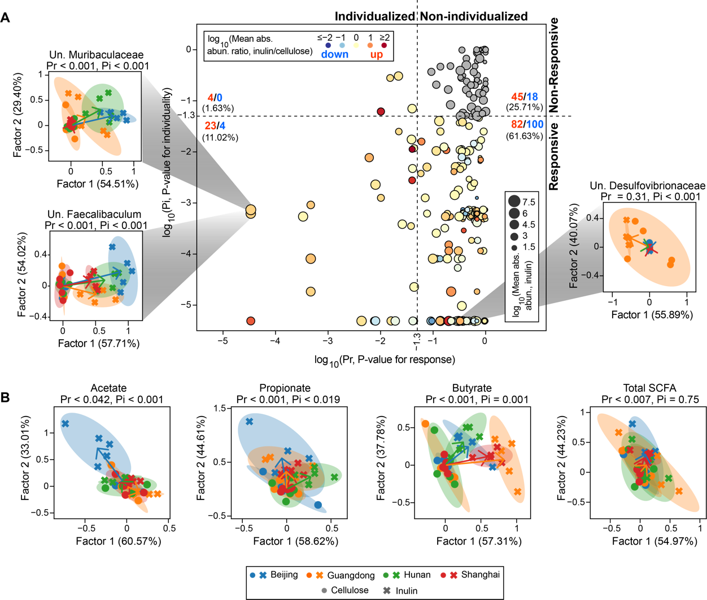

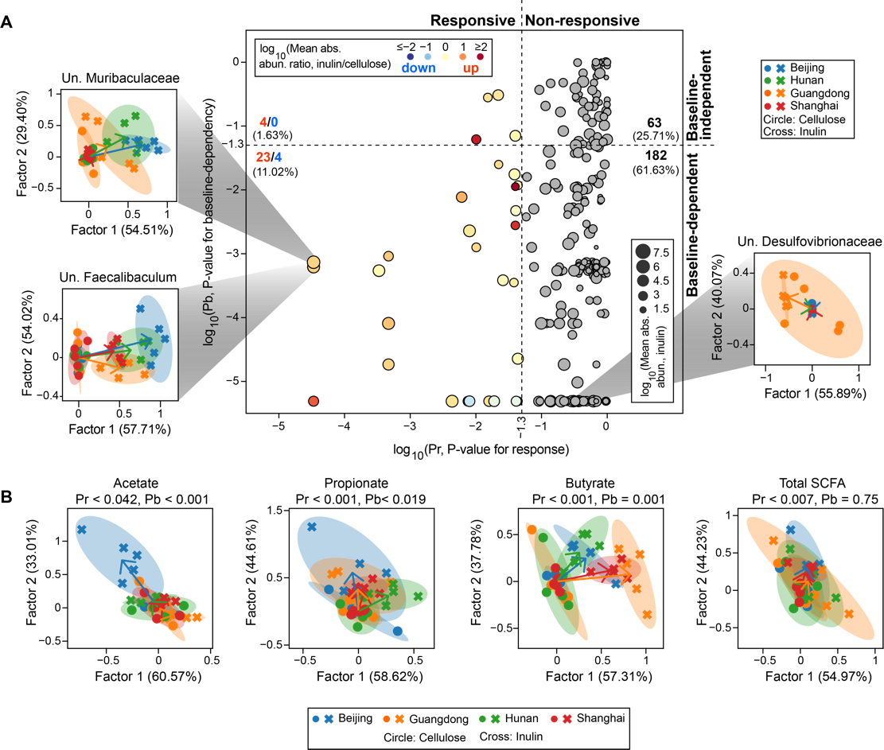

**Figure S12. (Related to Fig. 4) Individualized response analysis of bacterial species (A) and short-chain fatty acids (B) for resistant starch intervention.** The same figure legend applies as in the main text Fig. 4.

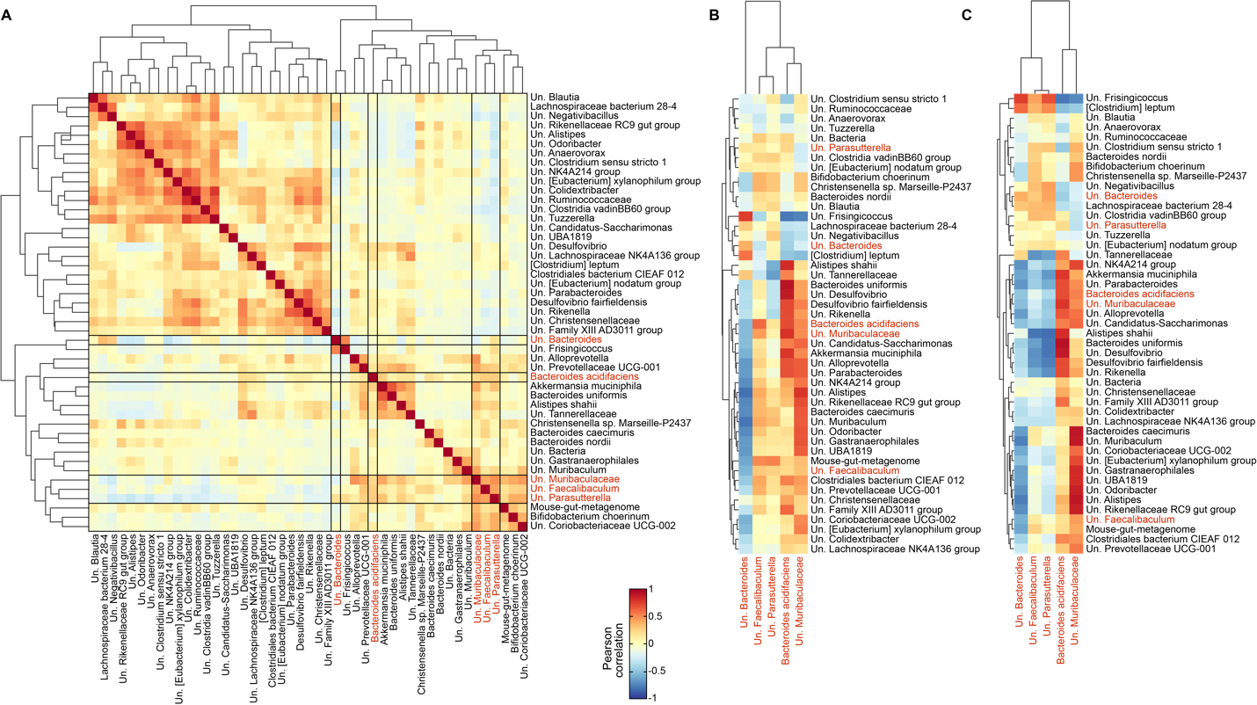

**Figure S13. (Related to Fig. 4) Pearson correlation between species w/ baseline-dependent responses (identified in the main text Fig. 4A) and inulin responders (identified in the main text Fig. 3C, highlighted in red). A**. Correlations were performed using absolute abundances at all time points. **B**,**C**. Correlations were performed using baseline absolute (B) or relative (C) abundances for species w/ baseline-dependent responses and total area under the curve of absolute abundances for inulin responders.

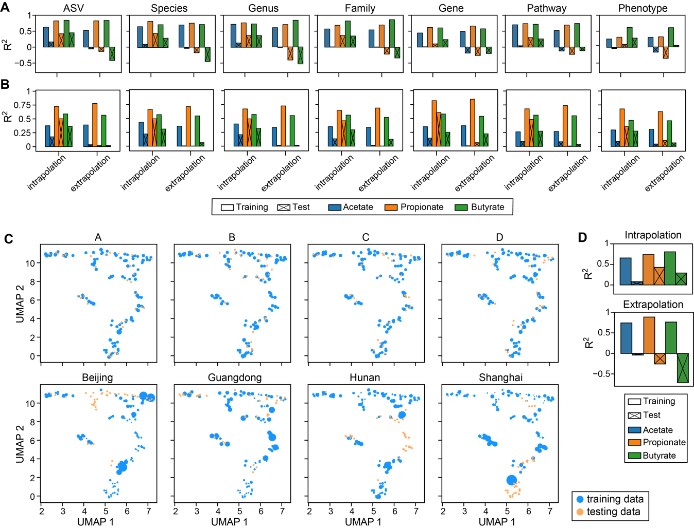

**Figure S14. (Related to Fig. 5) Poor performance of random forest model in predicting short-chain fatty acids (SCFAs) concentration (see Fig. 5B of the main text for results) cannot be rescued by using (A) alternative predictors, (B) alternative regression models, and (C,D) weighting of training samples. A**. Prediction accuracy using random forest regression model and taxonomic (ASV, Species, Genus, Family) or functional (Gene, Pathway, Phenotype) representation of gut microbiota as predictors. The abundances of genes, pathways and phenotypes were predicted using PICRUSt2. **B**. Prediction accuracy using MelonnPan and the same predictors as used in panel A. **C**. Sample weights under different data-splitting strategies. The weights of training samples closer to their corresponding test samples were assigned higher values, as indicated by larger circle sizes in a reduced two-dimensional UMAP (Uniform Manifold Approximation and Projection) space.The sample weight was calculated as 1/Pi-1, where Pi is the probability of sample i belonging to the training distribution and was estimated using random forest classifier (the same approach was applied to generate Receiver Operating Characteristics curves in Fig. 5D of the main text; see Methods in the main text for details). **D**. Prediction accuracy using random forest regression model built from weighted training data and absolute abundances of bacterial species as predictors.

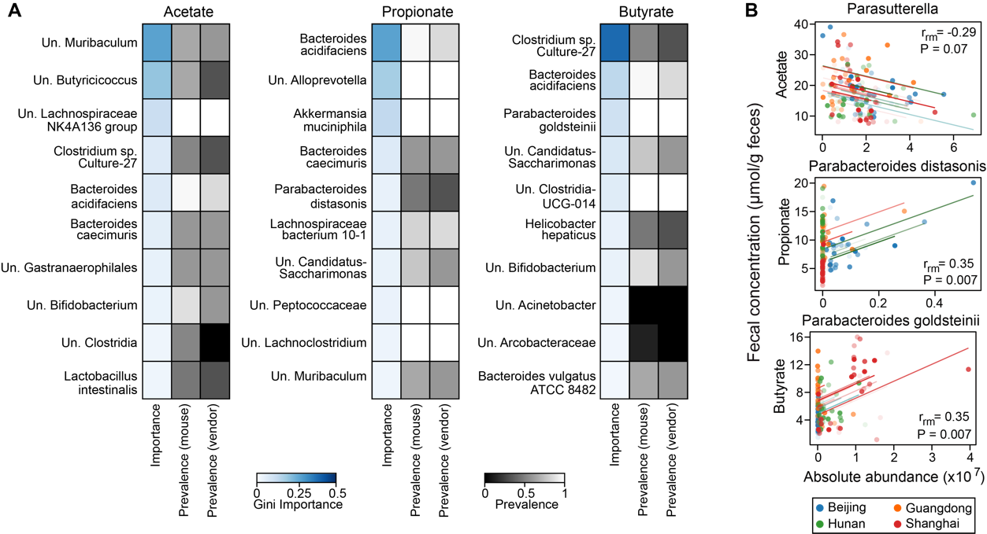

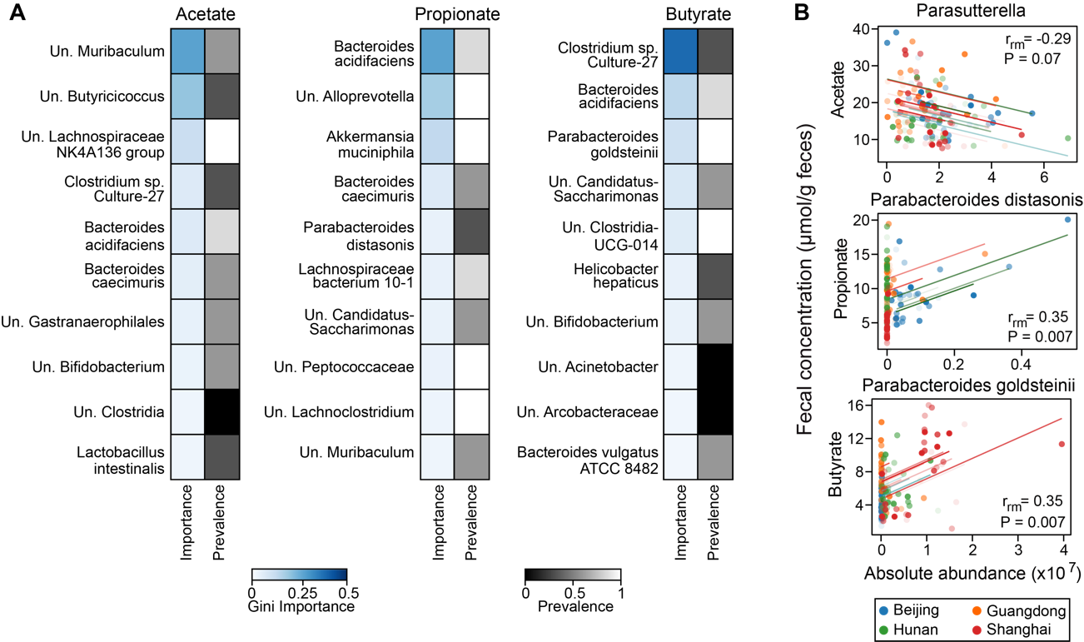

**Figure S15. Inferred short-chain fatty acid (SCFA) producers in inulin-treated mice vary depending on the inference approaches (Random forest regression vs. Repeated correlation analysis). A.** Random forest (RF) regression. For each SCFA, we showed top 10 bacterial species with the highest Gini importance score in model training using all data. The absolute abundances of bacterial species were standardized and filtered (threshold 10-5) by LASSO (least absolute shrinkage and selection operator) regression before passing to RF model. Several key hyperparameters in LASSO and RF were optimized using grid search cross-validation with R2 as the score metric. The vendor-level prevalence scores were obtained from Fig. 5C in the main text. **B**. Repeated correlation analysis. Longitudinal data and correlation trend lines are color-coded on a per-mouse basis. Repeated measures correlation coefficients (*r*rm) and FDR-corrected P-values are indicated in the plot.

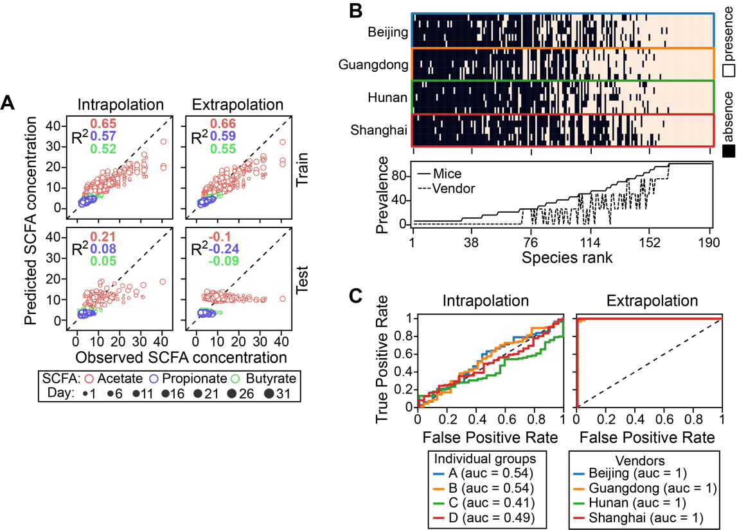

**Figure S16 (Related to Fig. 5) Prediction of short-chain fatty acid (SCFA) concentration from gut microbiota using data from resistant starch-treated mice**. The same figure legend applies as in the main text Fig. 5B-D (the same order).

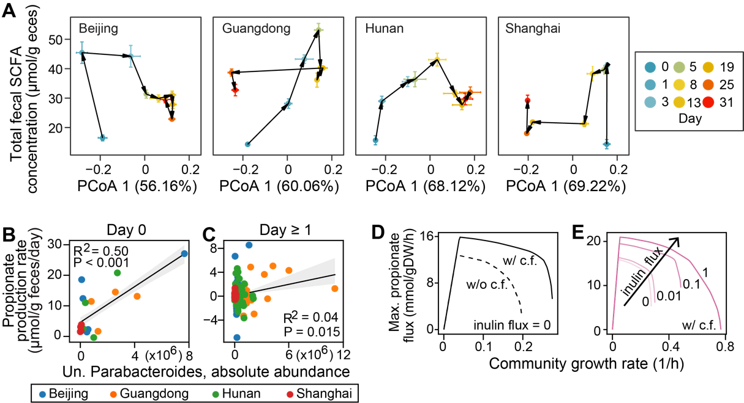

**Figure S17**. **(Related to Discussion)** The quantitative microbiome-metabolome relationship varies in a complex, time-dependent manner. **A**. Dynamics of gut microbiota composition (x-axis) and total SCFA concentration (y-axis) plotted on the same graph. We used the first principal coordinate score from PCoA (principal coordinate analysis) ordination to represent changes in gut microbiota composition (relative abundance) along the direction of maximum variance. Note that SCFA were substantially produced between day 0 and day 1, while gut microbiota composition only changes slightly. Points represent the mean PCoA scores across mice within each vendor and error bars represent the standard error of the mean. **B**-**E**. Potential producers and cross-feeding relationships for initial propionate production within a day of inulin treatment. **B**,**C**. Correlation of baseline unclassified (Un.) Parabacteroides absolute abundance with initial propionate production rates on day 0 (B) and rates in later days (C). Gray line: linear regression (R2 and P-value are indicated in the plot); shading area: standard error of the regression. **D**,**E**. Simulated effects of cross-feeding (c.f.) (D) and inulin availability (E) on growth and propionate flux of two-genera Bacteroides-Parabacteroides community. w/ c.f.: mixing Bacteroides and Parabacteroides in 1:1 ratio; w/o c.f.: mixing Parabacteroides and its clone mate in 1:1 ratio.

**8(Related to Materials and Methods)**